

The Texas Crime Prevention Association (TCPA) was created in 1976 as a 501(c) 3 nonprofit organization. Membership is comprised of law enforcement personnel, security professionals, loss prevention experts, business community leaders, and involved citizens, all concerned with proactive crime prevention.

TCPA is managed by a state board elected by the members and composed of nine affiliated but independent regions. Each region is governed by its board of directors.

TCPA is a TCOLE-certified training entity providing superior courses focused on proactive measures to stop crime before it occurs and utilizes Crime Prevention through Environmental Design (CPTED) strategies.

All TCPA training courses are evidence-based. Mandated classes are also offered throughout the year. Training is open to members and non-members in law enforcement, security professionals, and concerned citizens.

TCPA offers a Certified Crime Prevention Specialist (CCPS) certification, which can be obtained after completing three TCPA core academic courses and passing a comprehensive exam. These courses are offered throughout Texas by TCPA Regions and at some TCPA Conferences.

The courses cover physical security, crime prevention methodologies, crime reduction strategies for law enforcement, basic criminology, community engagement, long-term problem solving, public speaking, professional writing, and risk and vulnerability assessments related to security assessments/surveys.

TCPA’s 50th Annual Training Conference will be held July 21-24, 2025, at the Hilton Hotel & Conference Center in College Station, Texas. Early Bird Registration ends on March 1st.

.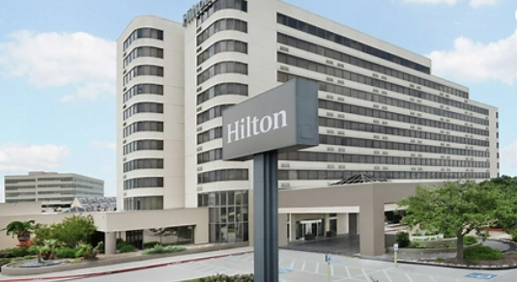

The Annual Conference brings together crime prevention experts and practitioners throughout our state. It is an excellent networking and learning opportunity.

The TCPA Conference provides TCOLE training hours for attendees and an opportunity to visit with vendors from the crime prevention community.

Opening Ceremony will kick off the conference Monday morning. In addition, there will be a Welcome reception Monday evening.



The General Membership meeting is during lunch on Wednesday and the Awards Banquet Luncheon is Thursday. The Awards Banquet recognizes many of our members for their achievements in crime prevention in their communities over the past year.

Check out <http://tcpa.wildapricot.org> for training offered throughout the year and for conference details.

If you have any questions, please contact TCPA President Vickie Stonaker at 214-223-5610 or email at [vickiestonaker@att.net](mailto:vickiestonaker@att.net)

We are looking forward to seeing you at the TCPA Conference!

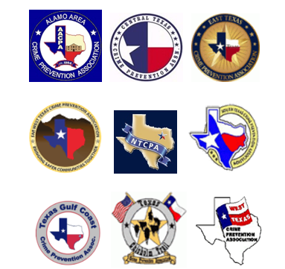



<http://tcpa.wildapricot.org>

**TEXAS CRIME**

**PREVENTION**

**ASSOCIATION**

[](http://www.tcpa.org/Welcome%20Page.htm)

<http://tcpa.wildapricot.org>