December, 2007

Alamo Area Crime Prevention Association

Meeting Location
Tuesday, December 18th 2007

Clear Springs Restaurant
606 W. Afton Oaks Blvd
( Loop 1604-between US281 & Stone Oak Parkway )

11:30 A.M. to 12:00 noon - Membership meeting
12:00 noon to 12:30 P.M. - AACPA Christmas Party & Gift Exchange
($20.00 limit)

VISITORS ARE ALWAYS WELCOME

Maps & Directions available on our web site: AACPA.NET
INVITE PROSPECTIVE MEMBERS TO OUR NEXT MEETING
- New Law Passed on "Saluting the Flag
WASHINGTON, D.C. - U.S. Senator Jim Inhofe (R-Okla) today praised the passage by unanimous consent of his bill (S.1877) clarifying U.S. law to allow veterans and servicemen not in uniform to salute the flag. Current
law (US Code Title 4, Chapter 1) states that veterans and servicemen not in uniform should place their hand over their heart without clarifying whether they can or should salute the flag. "The salute is a form of honor and respect, representing pride in one's military service," Senator Inhofe said. "Veterans and service members continue representing the military services even when not in uniform. "Unfortunately, current U.S. law leaves confusion as to whether veterans and service members out of uniform can or should salute the flag. My legislation will clarify this regulation, allowing veterans and servicemen alike to salute the flag, whether they are in uniform or not. "I look forward to seeing those who have served saluting proudly at Baseball games, parades, and formal events. I believe this is an appropriate way to honor and recognize the 25 million veterans in the United States who Have served in the military and remain as role models to others citizens. Those who are currently serving or have served in the military have earned This right, and their recognition will be an inspiration to others." This Bill was passed July 25, 2007. Let your veteran friends know about the passage of this bill.
Linda Furlow-Patty, 210-221-9686 (DSN 471), Provost Marshal Office
2404 N. New Braunfels Avenue, Stop 38, Fort Sam Houston, Texas 78234
Fax 210-221-9173

 | American Crime  Prevention Institute | 327 Townepark Circle  Louisville, KY 40243

November 26, 2007
Dear Colleague:

It’s hard to believe that the holiday season is upon us. The old adage that the older you get the faster time goes by is an indictment of my advancing years!

2007 was an exciting year at ACPI. The interactive crime prevention blog has been a huge success and continues to get better. If you haven’t visited the site or registered for complete access this would be an excellent time! Bill has posted a downloadable Holiday Crime Prevention Tips power point presentation that can be quickly modified to meet your individual department’s needs. Just “cut” the ACPI logo and insert your department’s logo. Log-on at www.crimepreventiononline.com and follow the simple registration directions.

We hope you find this new power point presentation useful to your ongoing crime prevention efforts. Remember, the blog is a free service that ACPI provides to all crime prevention practitioners!

During 2007, ACPI altered its web address and reengineered the website for easier use and convenience. The new web address is www.acpionline.com. Currently our IT people are in the process of changing the photos on the website to photos of crime prevention activities that our past participants have forwarded. If you have some crime prevention photos that you would like to share, forward them to Bill at wcarcara@aegissecuritydesign.com.

2007 also saw new partnerships formed with several state crime prevention associations; Illinois, Alabama, North Carolina, Texas, Kentucky, and Montana. Discussions are currently being conducted with several other associations that we hope will result in jointly sponsored crime prevention training courses offered in their respective areas. If you are interested in exploring the possibility of providing co-sponsored training contact Bill at 502-244-8558.

Lastly, the American Crime Prevention Institute is pleased to announce the 2008 crime prevention training schedule. As you will observe, ACPI is once again offering a wide variety of crime prevention topics throughout the United States.

All of ACPI’s Crime Prevention Through Environmental Design courses will be led by Timothy D. Crowe, the nation’s foremost CPTED authority.

ACPI is particularly excited about the Crime Prevention Trends: 2008 seminar that will focus upon targeted contemporary crime prevention issues confronting today’s crime prevention officers and specialists. ACPI is committed to providing the very best training courses and materials to crime prevention practitioners.

Basic Crime Prevention Certification Seminar (80 hour course)
January 28-February 8, 2008
Montgomery, Alabama
May 5-16, 2008
Louisville, Kentucky
October 6-17, 2008
Louisville, Kentucky
Basic Crime Prevention Through Environmental Design (40 hour course)
May 5-9, 2008
Louisville, Kentucky
October 6-10, 2008
Louisville, Kentucky
Advanced Crime Prevention Through Environmental Design (24 hour course)
May 12-14, 2008
Louisville, Kentucky
October 13-15, 2008
Louisville, Kentucky
Crime Prevention for Commercial and Retail Businesses (24 hour course)
August 25-27, 2008
Montgomery, Alabama
September 8-10, 2008
Greensboro, North Carolina
November 5-7, 2008
Santa Barbara, California
Current Trends in Crime Prevention: 2008 (24 hour course)
September 29-October 1, 2008
Albany, New York
October 22-24, 2008
Dallas, Texas
October 27-29, 2008
Orlando, Florida
November 10-12, 2008
Santa Barbara, California
December 1-3, 2008
Chicago, Illinois
Crime Prevention Through Community Engagement (24 hour course)
June 2-4, 2008
Chicago, Illinois

All ACPI past participants will be receiving a special announcement concerning the new Crime Prevention Through Community Engagement seminar…watch for it in your mail sometime in mid December. You won’t believe your eyes; but it’s true!

For further information on any of the courses or to register for a course, please visit our website, www.acpionline.com.

Additionally, all ACPI seminars are available on a cost effective contract basis. If you are interested in hosting a seminar, please contact our offices at 502-244-7304.

On behalf of Bill, Donna, and all the staff of ACPI, we wish you the very happiest of the holiday season and a healthy new year!

Sincerely,


Daniel P. Keller
Chief Executive Officer


Spoof Credit Union E-mails Could Ruin Consumers’ Holidays
A new, dangerous identity theft scheme is targeting credit union customers across the country. According to consumer and credit union groups, spoof e-mails are directing credit union customers to call a telephone number and confirm their personal information. Consumers who make the call do not reach their credit union, but instead end up on the telephone with a scam artist who wants to steal their identity.
Savvy consumers have increasingly learned to identify and delete spoof e-mails that falsely appear to originate from legitimate banks or credit card companies. Known as “phishing,” these e-mails direct consumers to a decoy Web site that allows the scammers to collect all the information they need to empty the customers’ bank accounts and ruin their credit.
“Phishing” scams have been around for years, but increasingly sophisticated criminals now send e-mails instructing consumers to call a telephone number instead of clicking on a link. This tactic, known as “vishing,” can be especially effective because consumers who encounter a live person are much more likely to let down their guard.
The latest “vishing” scam immediately disarms consumers by specifically warning about similar schemes. One recently circulated e-mail reads:
Dear Credit Union Customer,
We regret to inform you that we have received numerous fraudulent emails which ask for personal account information. The emails contained links to fraudulent pages that looked legit. Please remember that we will never ask for personal account information via email or web pages.
Because of this we are launching a new security system to make Credit Union accounts more secure and safe. To take advatage [sic] of our new consumer Identity Theft Protection Program we had to deactivate access to your card account.

To activate it please call us immediately.
The e-mail provides a telephone number with a U.S. area code, adding to its air of legitimacy. In an especially brazen move, the e-mail offers identity theft tips and links to the Federal Trade Commission’s identity theft prevention Web site. Consumers who think the e-mail is legitimate call the number and furnish sensitive information to a person they believe is a trusted credit union employee. Only when their identity is stolen do they realize it was all a scam.
These “vishing” scams combine the “phishing” ploy with a Web-based telephone scheme. The telephone numbers that appear in these e-mails are set up through VoIP, which is an Internet-based telecommunications service. Even though the phone number appears to be based in a familiar U.S. area code, the scammers are most likely in other countries and impossible to track down.
Consumers who receive this or any other unexpected e-mail or phone call seeking personal information should not respond. Consumers who have concerns about their account should contact their credit union by calling the telephone number that appears in the local directory or on their periodic statements. Never click on a link or call a telephone number that appears in an unexpected e-mail.
Sincerely,
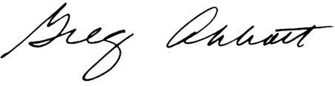
Greg Abbott Attorney General of Texas
- Code Amber News October 2007
From: Code Amber (listserv@codeamber.net)
To: Alamo Area Crime Prevention Association
Hello Alamo Area Crime Prevention Association,
In September the folks at Live Sales Staff began providing live support for sales of our Amber Sticks and the Safety NET Kids video.
They are providing this service to Code Amber at no charge in support of our efforts. We are very grateful to them as the service has increased our sales of both products last month. We even had one inquiry that resulted in an order for 40 Amber Sticks! Live Sales Staff can provide the same outstanding service to any business, on line or off, and can be set up within a couple of days.
If you, or someone you know would be interested in having live, 24 hour, seven days a week customer support for sales of products or services, please contact Carmen Koop at carmen@livesalesstaff.com for more information. Please tell him Code Amber sent you.
And feel free to ask them any questions you might have regarding the Amber Stick and the Video by clicking on the link on our product pages. See below for more information.
Amber Stick New Lower Price and Version 2 Software now Available. The new version collects all of the information for Children, Adults and your Pets on one stick.
Code Amber endorses, and is your source for, the Amber stick, the first and only fully portable Child Identification
system.
The Amber stick (tm) is the next generation of Child Id software. It is fully contained on a USB Flash drive so there is no software to download and install.
New lower price. The Version 2 Amber Stick is only $29.95 with free shipping.
Our sponsor, DNAPrint Genomics, also provides a DNA Analysis in PDF format which can be uploaded to the Amber Stick through an additional feature added to the new Version 2 software. Click the DNAPrint logo on any Code Amber page for complete information on this leading edge new product.
For more information on the Amber stick (tm), and to order through Code Amber, please visit http://codeamber.org/idkits.html?nl
The software on the USB drive is password protected and the data is completely encrypted to ensure your privacy. If the USB device is lost the data is unreadable without the password which you set when you first use the software (the password can be changed at anytime).
Simply plug the USB drive into your computer (all computers made in the last 10 years have at least one USB port) and the software automatically starts and prompts for the password. Enter your data and up to three
photographs of each child, pet or person you want to protect and done. The Amber stick will hold information on up to 100 individuals.
If a child or person goes missing you simply hand the USB device to the police officer and give them the password to the software. Almost all police cars now have an onboard laptop computer which is connected to the police station over a wireless network so the critical information is available to the entire department within minutes. No more searching for a photograph to scan or the need for the officer to take critical descriptive information by hand.
Missing persons and Missing pets flyers can be printed at the click of the mouse as well.
For more information on the Amber stick (tm), and to order through Code Amber, please visit http://codeamber.org/idkits.html?nl
All sales help to fund the daily operation of Code Amber. Volume discounts are available. Please contact us for details at admin@codeamber.org. Safety N.E.T. Kids DVD still only $14.95.
Code Amber has fully endorsed the Safety NET Kids video since we first reviewed it in November 2003. You can read more about it on our Featured Sites ( http://codeamber.org/featured.html ) page as well as some other
reviews and endorsements.
The video runs 30 minutes and covers topics such as how to recognize and avoid a dangerous stranger, what to do if a stranger comes to the door or calls while your child is home alone and much more.
For more information please visit http://codeamber.org/video.html?nl
Code Amber Sponsor Links - Special Offer
Our Sponsor Links have been a great success. Many supporters are repeat buyers and we thank you.
For a limited time we are offering a FREE Code Amber "Dot" to anyone who purchases an 8 week Code Amber Sponsor Link. This offer will end in a few weeks so take advantage now.
Sponsor links display on all of the Code Amber sites, (CodeAmber.org, CodeAmber.com, CodeAmberKids.com).
For complete information and order information please visit http://codeamber.org/sponsor_links.html
Additional discounts are available for longer terms. Contact admin@codeamber.org for pricing.
A Special Thank You to Our Supporters
Code Amber does not receive any grants or funding from any government agency. Code Amber is provided as a free public service by our family company, Bighits.com with additional support from you, the web community.
Primary funding by BigHits.com is provided through statistical and promotional services provided to over 60,000 web masters worldwide. If you have a web site you may want to visit http://bighits.net to see how BigHits can help you promote your site and generate more visitors for free.
Code Amber is not a non-profit organization and we have never presented ourselves as such. No contribution to Code Amber is tax deductible except as a business expense. Please consult your accountant regarding expensing contributions to Code Amber.
In addition I would like to thank all of you who have shown your support through direct contributions and Link sponsorships as well as by buying a Code Amber Digital ID System or a Safety NET Kids video.The Code Amber project will continue to be a success as a result of the support of the Web community.
For additional information please visit http://codeamber.org/support.html .
For the video please visit http://codeamber.org/video.html?nl
To make a direct contribution visit http://codeamber.org/donate.html
**********************************************************
Please forward this email to anyone you know who may be able to join us.
Thank you for your time and continued support.
Sincerely,
Bryant Harper
Founder
CodeAmber.org
- 3rd Eye Surveillance Systems – A TCPA Sponsor


StarTech Outlet Inc. – A TCPA Sponsor



StarTech Outlet – The Industry Leader In Spy Cams & Surveillance Equipment

 |  | World's Smallest Full Feature Pocket DVR  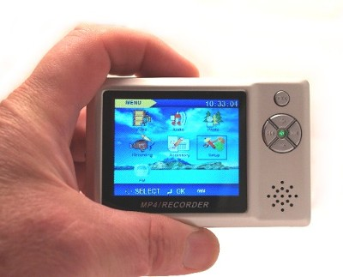  Amazing features and quality in a super small sub-mini video/audio recorder package. At only 3-1/2 x 2-1/4 x 1/2 inches, entire recorder can fit into a pack of cigarettes.  On sale now only $199 |  | 
  Micro DVR with Button and Screw Camera
  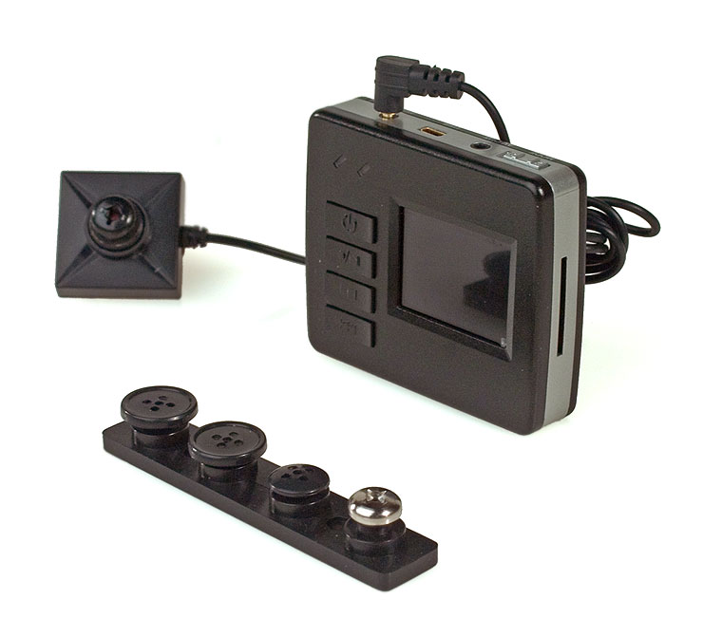
  Small is in! This tiny micro DVR is ready for work straight out of the box; it comes with its own Button/Screw Camera that is powered by the micro DVR.
  Stealthcam Surveillance Technology
  
  WorldTracker GPRS Extreme Real Time Tracking Updates every 15 Second !
  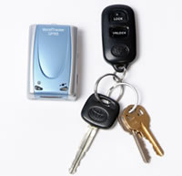
  New WorldTracker GPRS, the first tracking device with real-time updates every 15 seconds. Direct GPRS data connection gives you the most accurate and reliable tracking data ever

 |  | 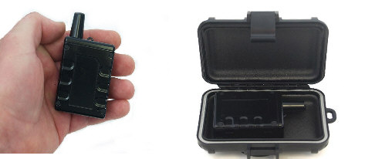  The CDMA/PRO enables the operator to obtain a location fix inside buildings, parking garages, and other dense urban areas.  There is no external antenna required and the device does not need to "see the sky" as do many GPS tracking devices. CDMA (Code Division Multiple Access) technology provides the most reliable and highest capacity mobile data access available today.  The unit works effectively inside the trunk of a vehicle, under vehicle, in armored vehicles, indoors, and other locations where a standard GPS device would be ineffective.  ON SALE NOW ONLY $559.00 Includes Weatherproof Magnetic Mount $59 value Box FREE
  SIM Recovery PRO
  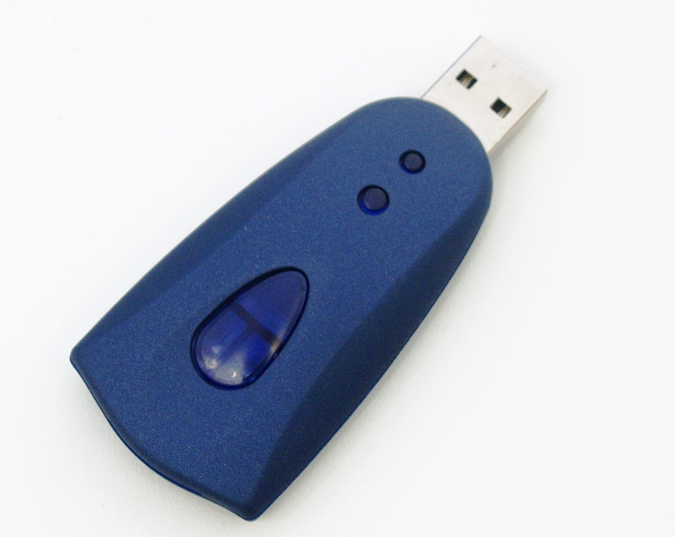
  Ideal for restricting/examining kid's or employees cell phone usage.
  The SIM Recovery Pro is a SIM card application for Windows. Using the Recovery PRO software with your computer, you can save, edit and delete your phone book and short messages (SMS) stored in your SIM card.
  On Sale Now $129.95
  NEW! CDMA/PRO Tracker
  with Cell Assist and Mag Case
  The CDMA/PRO with "cellular assist" mini tracker uses the most advanced location techniques available to determine the location of an asset.
  NEW! Universal Cell Phone Recorder [CX-R]
  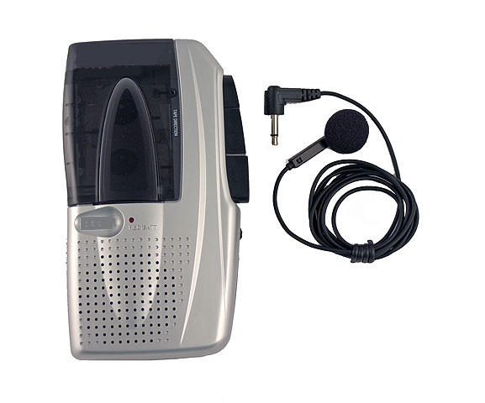
  Great for quick and simple "on-the-go" recordings of your important cell phone, pay phone, hotel phone, or home phone conversations.
  Simply place the universal cell phone recording adaptor into your ear, plug into recorder, and press record button. That's it!
  On Sale Now $79.00



We continually shop the globe to bring you the latest up-to-date, high tech quality spy gadgets and equipment at the most reasonable prices on the web. Visit us often as we are continually updating our product selection.

