November, 2007

Alamo Area Crime Prevention Association

Meeting Location
Tuesday, November 20th 2007

12 noon - Membership meeting
Training class 8 A.M. - 12 noon
Membership meeting immediately following
Identification of Stolen Vehicles for Field Officers
Lead Instructor -John Bailey, Comal Co. SO
4 hours TCLEOSE credit
This course is FREE - limited to 30
Remember to RSVP to:
Cpl Tim Kolbe, Comal Co SO
(830)620-3400 - soatpk@co.comal.tx.us
(see Training Page for course details)
Comal Co SO Training Room
3005 W San Antonio
New Braunfels TX 78130)
AACPA Membership meeting immediately following the training
Lunch provided for AACPA members

VISITORS ARE ALWAYS WELCOME

Maps & Directions available on our web site: AACPA.NET

DOOR PRIZES - - DOOR PRIZES - - DOOR PRIZES - - DOOR PRIZES

INVITE PROSPECTIVE MEMBERS TO OUR NEXT MEETING


Tuesday November 20, 2007
8 AM - 12 noon
Doors open 8AM
Identification of Stolen Vehicles for Field Officers
(4 hours TCLEOSE)
Comal Co SO Training Room
3005 W San Antonio
New Braunfels TX 78130
(830)620-3400
Class size limited to 30, so remember to RSVP to:
Cpl. Tim Kolbe
Crime Prevention Community Services
(830)620-3400
soatpk@co.comal.tx.us
This course is FREE

The attendees will learn techniques for identifying stolen vehicles in the field. Practical applications and resource materials provided during this course, will facilitate learning and assist the student in future self-directed applications in the detection of stolen vehicles.
The Lead Instructor is John Bailey, Comal Co SO Auto Theft Investigator
Comal Co. is a member of the Sheriff's Combined Auto Theft Task Force
This course is free
Comal Co. will report TCLEOSE hours for TX Peace Officers.
Trainees must provide PID number for reporting or they cannot report your hours.
AACPA's Monthly meeting will immediately follow the training
(12 noon - 12:30)
Lunch will be provided for AACPA members

CPCA members

As many of you know, the 2007-2008 Crime Prevention Month Kit, Protecting Children and Youth, is now available. For an electronic copy of the kit, please visit the NCPC website http://www.ncpc.org/about/crime-prevention-month/2008%20cpm%20kit.pdf/view. If you would like to order copies of the kit, please call 1-800-NCPC 911 or visit our online store http://mcgruffstore.org/crprmoackit23.html. Single copies of the kit are free and bulk orders are $2 per kit. If you have any questions regarding the kit, please feel free to contact me using the information listed below.
Thank you,
Kate
Katherine G. Black, Manager, Crime Prevention Coalition of America
National Crime Prevention Council, 2345 Crystal Drive, Fifth Floor, Arlington, VA 22202
tel 202-261-4163, fax 202-296-1356 kblack@ncpc.org www.ncpc.org

Check out this web site and Conference information if:
Your Chief or Sheriff is not sure a volunteer program is right for their agency;
Your agency is interested in starting a law enforcement volunteer program;
You have an existing program and are looking for training for your Officers and or Civilians.

Texans Lookin' Out For Texans

http://tloft.org

Please forward to your Citizen Patrol members, Volunteers in Police Service members, your Wise Eyes members and your Neighborhood Watch Groups.

Thank you

Mark Brazelton

Special Offer for all TCPA members, family, and friends:

Garage Security, a member of the NTCPA chapter, is offering a special discount (33%) for our garage door closing device, the Garage Butler, to all members. The Garage Butler is a viable solution to help preventing property crime (or worse) by preventing garage doors from remaining open while unattended. It even prevents garage doors from staying open all night by detecting when it gets dark and automatically closing the garage door. Very easy to install by the homeowner. More information about the Garage Butler can be found at www.securemygarage.com. However, do not order from the website, as that is the general public pricing. Please use the attached order form and either email to bennett.gd@sbcglobal.net or mail to Garage Security, 1507 Wysong Dr., McKinney, TX 75069. Mailed-in payments can be in the form of credit card, check, or money order. You may also order by phone by calling 214-336-6946.

Summer is over and the number of open garage doors will go down. Now is the time to prepare for next spring and summer. Get a Garage Butler and get peace of mind. Makes for a great Christmas present, too!

Thank you,
Gordon Bennett, Owner
Garage Security

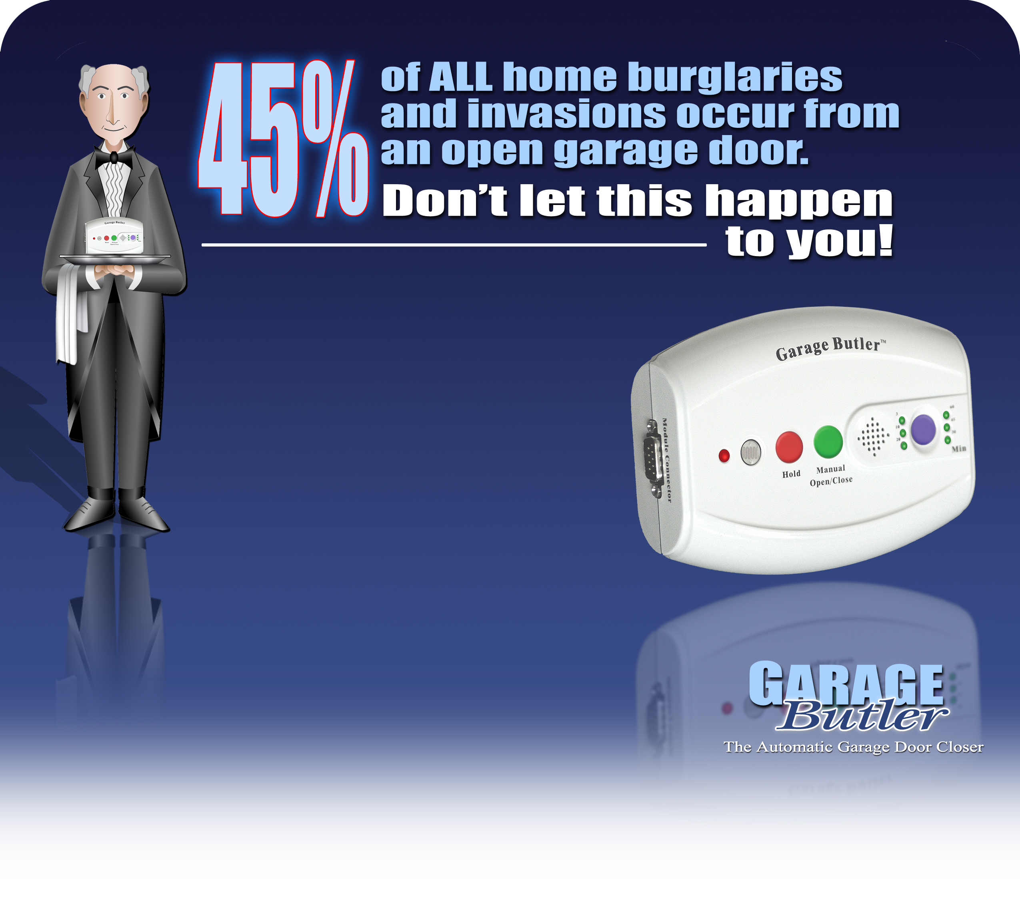

Sheriff Joe Arpaio is at it again

Maricopa County, Arizona was spending approx. $18 million dollars a year on stray animals, like cats and dogs. Sheriff Joe Arpaio offered to take the department over, and the County Supervisors said okay. The animal shelters are now all staffed and operated by prisoners.
They feed and care for the strays. Every animal in his care is taken out and walked twice daily. He now has prisoners who are experts in animal nutrition and behavior. They give great classes for anyone who'd like to adopt an animal. He has literally taken stray dogs off the street, given them to the care of prisoners, and had them place in dog shows.
The best part? His budget for the entire department is now under $3 million.
Teresa and I adopted a Wemeriner from a Maricopa County shelter two years ago. He was neutered, and current on all shots, in great health, and even had a microchip inserted the day we got him. Cost us $78.
The prisoners get the benefit of about $0.28 an hour for working, but most would work for free, just to be out of their cells for the day. Most of his budget is for utilities, building maintenance, etc. He pays the prisoners out of the fees collected for adopted animals.
I have long wondered when the rest of the country would take a look at the way he runs the jail system, and copy some of his ideas. He has a huge farm, donated to the county years ago, where inmates can work, and they grow most of their own fresh vegetables and food, doing all the work and harvesting by hand. He has a pretty good sized hog farm, which provides meat, and fertilizer. It fertilizes the Christmas tree nursery, where prisoners work, and you can buy a living Christmas tree for $6 - $8 for the Holidays, and plant it later. We have six trees in our yard from the Prison.
Now he's in trouble with the ACLU again. He painted all his buses and vehicles with a mural that has a special hotline phone number painted on it, where you can call and report suspected illegal aliens. Immigrations and Customs Enforcement wasn't doing enough in his eyes, so he had 40 deputies trained specifically for enforcing immigration laws, started up his hotline, and bought 4 new buses just for hauling folks back to the border. He's kind of a "Git-R Dun" kind of Sheriff.
To those of you not familiar with JOE ARPAIO: He is the Maricopa Arizona county sheriff and he keeps getting elected over and over. These are some of the reasons why:
- He has jail meals down to 40 cents a serving and charges the inmates for them.
* He stopped smoking and porno magazines in the jails. He took away their weights and cut off all but "G" movies.
* He started chain gangs so the inmates could do free work on county and city projects.
* Then he started chain gangs for women so he wouldn't get sued for discrimination.
* He took away cable TV until he found out there was a federal court order that required cable TV for jails. So he hooked up the cable TV again. But he only let in the Disney Channel and the Weather Channel. When asked why the weather channel he replied, so they will know how hot it's gonna be while they are working on my chain gangs.
* He cut off coffee since it has zero nutritional value. When the inmates complained, he told them, "this isn't the Ritz Carlton - if you don't like it, don't come back."
* He bought Newt Gingrich's lecture series on videotape that he pipes into the jails. When asked by a reporter if he had any lecture series by a Democrat, he replied that a democratic lecture series might explain why a lot of the inmates were in his jails in the first place.
* With temperatures being even hotter than usual in phoenix (116 degrees just set a new record), the Associated Press reports that about 2,000 inmates living in a barbed-wire-surrounded tent encampment at the Maricopa County Jail have been given permission to strip down to their government-issued pink boxer shorts.
On Wednesday, hundreds of men wearing boxers were either curled up on their bunk beds or chatted in the tents, which reached 138 degrees inside the week before. Many were also swathed in wet, pink towels as sweat collected on their chests and dripped down to their pink socks. "it feels like we are in a furnace," said James Zanzot, an inmate who has lived in the tents for 1 year. "it's inhumane."
Sheriff Joe Arpaio, who long ago started making his prisoners wear pink and eat bologna sandwiches, is not one bit sympathetic.
He said Wednesday that he told all of the inmates: "It's 120 degrees in Iraq and our soldiers are living in tents too, and they have to wear full battle gear, but they didn't commit any
crimes, so shut your damned mouths!"
Maybe if all jails and prisons were like this one there would be a lot less crime and/or repeat offenders. Criminals should be punished for their crimes - not live in luxury until it's time for their parole, only to go out and commit another crime so they can get back in to live on taxpayers money and enjoy things taxpayers can't afford to have for themselves.
Vote him in for PRESIDENT!!!!!!!!!!!!

Laura "KAT" Tobias
AACPA-1st VP/TCPA Civilian at Large
radgirl@satx.rr.com
www.aacpa.net
(210) 381-7995


Subscriptions | Office of the Attorney General | Consumer Protection Page

CONSUMER ALERT
Jury Duty Scam Just Another ID Theft Trick
The FBI and other law enforcement agencies around the country have re ported the resurgence of an old trick known as the jury duty scam.
In this scam, potential victims receive calls from people posing as court officers. The caller informs the victim that he or she failed to appear for jury duty and that a warrant has been issued for his or her arrest. After alarming the victim, the caller then seeks to "confirm" the victim's Social Security number and other personal information. After divulging this information, the victim is often told that the entire matter can be instantly dismissed by paying a fine. All the victim needs to do is provide a credit card or checking account routing number.
By the time the call ends, the scammer has all the information necessary to open lines of credit under the unsuspecting victim's name. Identity thieves can quickly empty the victim's bank accounts or run up staggering credit card bills.
As with many ploys to obtain consumers' personal information, it is likely that many of these identity thieves are actually thousands of miles away, often in other countries and out of reach of U.S. law enforcement. Under this scheme, criminals simply go through the phone book hoping that sooner or later someone will provide the sensitive information they need to steal an identity.
This ploy is particularly effective because it causes victims to react immediately out of fear, rather than taking the time to reflect about the information being requested. While citizens could face legal consequences for failing to respond to a valid jury summons, legitimate court officers would never leave threatening messages on someone's voicemail to demand personal information and immediate payment of a fine.
Consumers who receive such a call can verify whether they must appear for jury duty by calling their local courthouse or district court. Consumers should NEVER hand over personal information in response to an unsolicited telephone call or e-mail, no matter how legitimate it might appear.
For more information, contact the Office of the Attorney General at (800) 252-8011 or visit the Attorney General's Web site at www.oag.state.tx.us
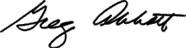
Greg Abbott
Attorney General of Texas

